**S.V.G.M. GOVERNMENT DEGREE COLLEGE**

**KALYANDURG**

 **NAAC with ‘B’ Grade**





**Coaching for**

**Competitive Exams**

**&**

**P.G Entrance**

**2021-2022**

**Circular**

Date: 01-02-2022

To: All Students

Subject: Free Competitive Examinations Training Program

With the kind permission of Dr. D. Jayarama Reddy, Principal of SVGM Govt. Degree College, Kalyandurg, we are pleased to announce that Sri M. Lakshmi Narayana, Lecturer in Commerce, will be conducting a Free Competitive Examinations Training Program.

Program Details:

Duration: 30 days

Commencement Date: 3rd February 2022

Training Includes:

PG M.Com and other Competitive exams related with Accountancy Subject Example Junior Accounts Officer.

Entrance Preparation (30 days): Comprehensive coaching covering essential topics such as Financial Accounting, Business Organization & Management, Cost & Management, Business Economics and Income Tax.

For: PG M.Com Entrance Preparation (30 days)

Registration:

Interested students are requested to register for the Free Competitive Examinations Training Program at the Commerce Department.

Sd/-

M. Lakshmi Narayana

Lecturer in Commerce

SVGM Govt. Degree College, Kalyandurg

**Summary Report:**

**Free Competitive Examinations Training Program**

With the gracious permission of Dr. D. Jayarama Reddy, Principal of SVGM Govt. Degree College, Kalyandurg, Sri M. Lakshmi Narayana, Lecturer in Commerce spearheaded a commendable initiative to provide free Competitive Examinations training to students. The program commenced on 3rd February 2022 and spanned a duration of 30 days.

**Overview:**

The Free Competitive Examinations Training Program catered to the diverse needs of students preparing for a multitude of competitive exams, including PG M.Com Entrance and Other Competitive Exams related with Accounting. Under the expert guidance of Sri M. Lakshmi Narayana, U. Eswar Reddy and B.K.Ganesh Rao participants received comprehensive coaching and support to enhance their preparation.

**Training Highlights:**

**PG Computer Science Entrance Preparation (30 days):** The program offered rigorous coaching covering essential subjects such as Financial Accounting, Business Organization & Management, Cost & Management, Business Economics, Income Tax and fundamentals of Computers.

**Mock Exam:**

As a pivotal component of the training program, a mock exam was conducted on 15th March 2022, replicating the format and conditions of PG M. Com Entrance exams. This mock exam provided participants with an invaluable opportunity to assess their preparedness and refine their strategies for the actual examinations.

**Conclusion:**

The Free Competitive Examinations Training Program, conducted under the leadership of Sri M. Lakshmi Narayana, has made a significant impact on the preparation and confidence levels of students aspiring to Commerce Subjects in competitive exams. Through dedicated coaching, expert guidance, and rigorous mock tests, participants have been empowered to pursue their academic and career aspirations with confidence.

Sincerely,

M. Lakshmi Narayana

Lecturer in Commerce,

SVGM Govt. Degree College, Kalyandurg.

**2021-22**

**Model PG Entrance Exam**

**Department of Commerce,**

**SVGM Govt. Degree College, Kalyandurg**

**Multiple Choice Questions Answer all the Questions 25 x 1 = 25**

**Section – A: Financial Accounting**

**1.** Which of the following is a contra account?

a. Prepaid expenses b. Accumulated depreciation

c. Accounts receivable d. Common stock

**2.** What is the purpose of the trial balance?

a. To ensure that all transactions are recorded

b. To prepare financial statements

c. To identify errors in the accounting records

d. To calculate net income

**3.** Which of the following is an example of an intangible asset?

a. Buildings b. Land c. Patents d. Inventory

**4.** What is the formula for calculating net income?

a. Net Income = Revenue – Expenses

b. Net Income = Assets - Liabilities

c. Net Income = Equity – Dividends

d. Net Income = Cash Flow from Operations

**5.** How are dividends treated in the statement of cash flows?

a. Operating activities b. Investing activities

c. Financing activities d. Non-cash activities

**Section – B: Business organization & Management**

**6.** In the context of management theories, which theory emphasizes the importance of employee motivation and satisfaction?

a. Classical management theory b. Behavioral management theory

c. Scientific management theory d. Contingency management theory

**7.** The process of monitoring, comparing, and correcting work performance is known as:

a. Planning b. Controlling c. Leading d. Organizing

**8.** Which leadership style involves a leader making decisions without consulting team members?

a. Autocratic leadership b. Democratic leadership

c. Transformational leadership d. Laissez-faire leadership

**9.** What does the term "span of control" refer to in management?

a. The number of levels in the organizational hierarchy

b. The number of subordinates a manager can effectively supervise

c. The extent of authority held by top-level management

d. The range of products a company offers

**10.** Which organizational structure is characterized by a clear chain of command and a strict division of labor?

a. Matrix structure b. Functional structure c. Divisional structure d. Network structure

**Section – C: Income Tax**

**11.** Which of the following is considered a "taxable event" in the context of income tax?

a. Receiving a gift from a family member b. Selling a personal car

c. Winning a lottery prize d. Donating to a charitable organization

**12.** What is the alternative minimum tax (AMT) designed to prevent?

a. Excessive tax deductions for high-income individuals

b. Double taxation of dividends c. Fraudulent tax reporting

d. Unfair taxation of low-income individuals

**13.** What is the purpose of Form W-4 in the United States?

a. To report income from self-employment b. To request a tax refund

c. To determine the amount of federal income tax to be withheld from an employee's pay check

d. To claim tax credits for education expenses

**14.** Which of the following is a tax-deductible expense for a self-employed individual?

a. Personal clothing expenses b. Commuting costs

c. Home office expenses d. Entertainment expenses for personal use

**15.** What is the standard mileage rate for business-related driving as of 2023?

a. $0.14 per mile b. $0.22 per mile

c. $0.38 per mile d. $0.56 per mile

**Section – D: Fundamentals of Computers**

**16.** What is the purpose of a firewall in computer security?

a. Protect against hardware failures

b. Prevent unauthorized access to a computer or network

c. Manage internet connections d. Execute software programs

**17.** Which programming language is commonly used for web development and design?

a. Python b. Java c. HTML d. C++

**18.** What does ISP stand for?

a. Internet Service Provider b. Information Storage Processor

c. Integrated System Processor d. Intelligent Security Protocol

**19.** What is the purpose of the BIOS (Basic Input/Output System) in a computer?

a. Execute software programs b. Manage internet connections

c. Control hardware components and initiate the boot process

d. Store permanent data

**20.** What is the function of spread sheet software?

a. Create and edit documents

b. Perform mathematical calculations and data analysis

c. Manage internet connections d. Protect against viruses

**Section – E: Cost & Management Accounting**

**21**. What is the formula for calculating the payback period of an investment?

a. Initial Investment / Annual Cash Inflows

b. Annual Cash Inflows / Initial Investment

c. Initial Investment × Discount Rate

d. Annual Cash Inflows × Discount Rate

**22.** Which type of variance is the difference between the actual quantity of input used and the standard quantity allowed for actual output?

a. Material price variance b. Material efficiency variance

c. Labor rate variance d. Labor efficiency variance

**23.** What is the formula for calculating the return on investment (ROI)?

a. (Net Income / Average Total Assets) × 100

b. (Net Income / Initial Investment) × 100

c. (Initial Investment / Net Income) × 100

d. (Average Total Assets / Net Income) × 100

**24**. In a process costing system, how are equivalent units calculated for direct materials and conversion costs?

a. Direct materials: Physical units × Percentage completion, Conversion costs: Physical units

b. Direct materials: Physical units, Conversion costs: Physical units × Percentage completion

c. Direct materials: Physical units × Conversion costs: Physical units

d. Direct materials: Physical units, Conversion costs: Physical units

**25.** What is the formula for calculating the labor rate variance?

a. (Actual Hours × Actual Rate) - (Actual Hours × Standard Rate)

b. (Standard Hours × Actual Rate) - (Actual Hours × Standard Rate)

c. (Actual Rate × Standard Hours) - (Actual Rate × Actual Hours)

d. (Actual Hours × Standard Rate) + (Actual Rate × Actual Hours)

**Photo Evidences**:

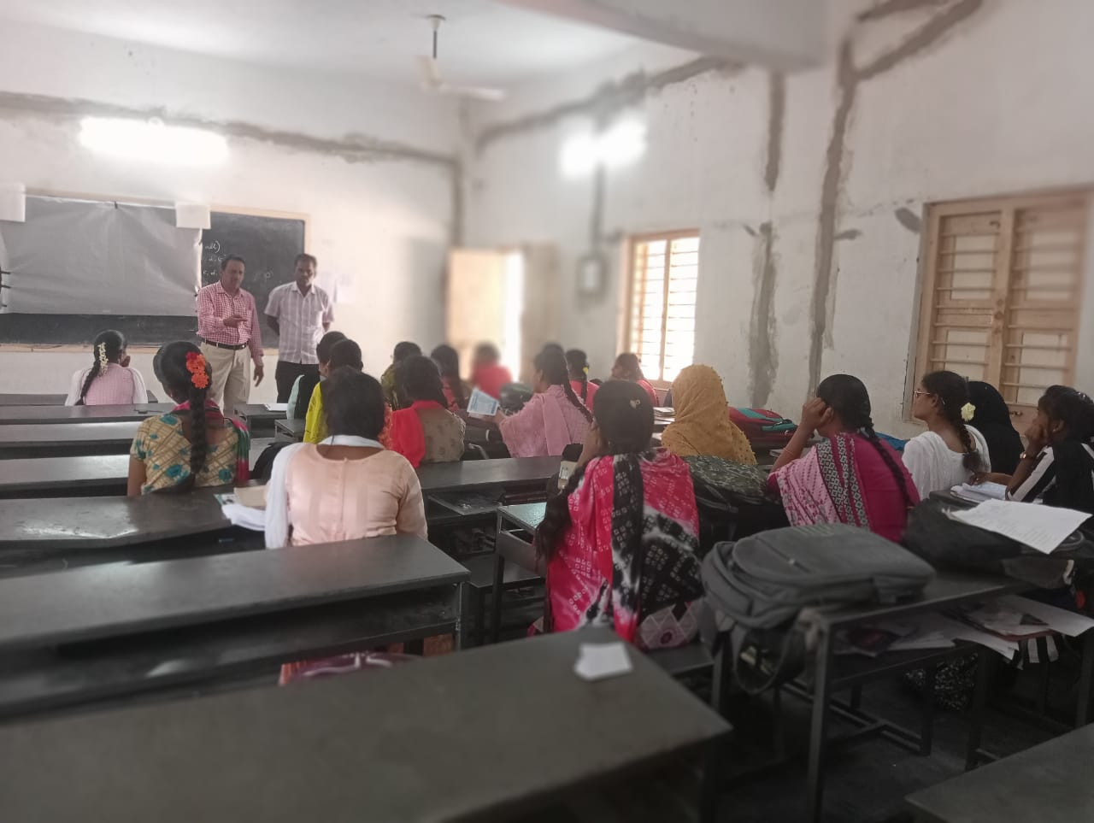

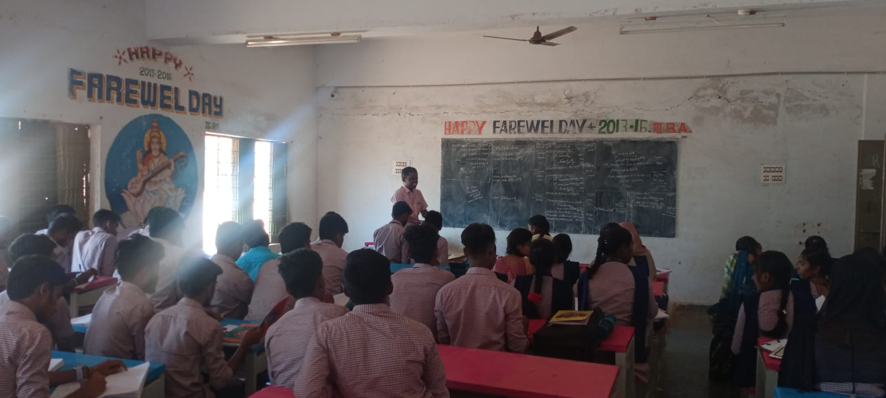

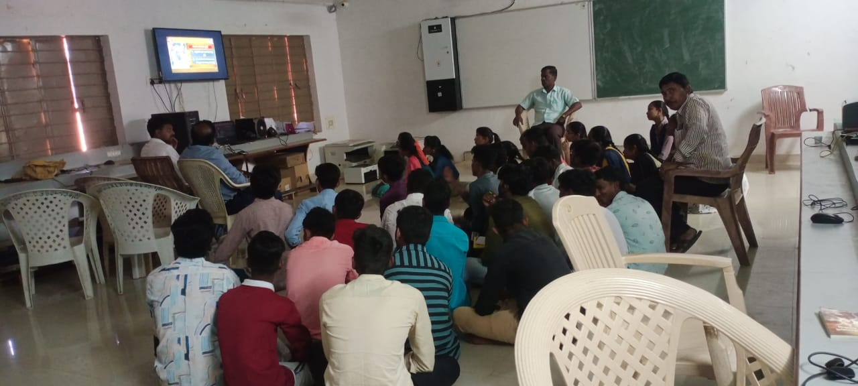

Photos for Evidence

